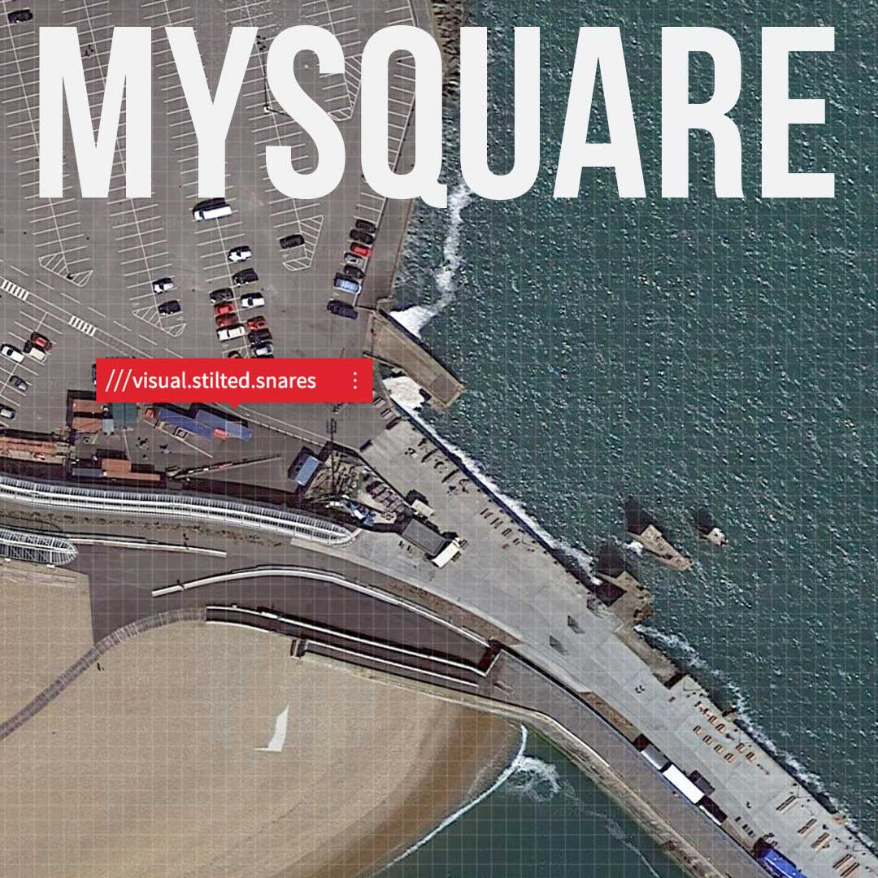

SUBMISSION FORM

Thanks for participating in our My Square Project. Please send an email to mysquare@folkestonefringe.com with this completed form and the work that you have produced so we can upload to our My Square Online Map.
You can also see what others have been up to by viewing: www.tinyurl.com/y6ken3ex

Please complete each of the following questions. Some questions are optional.

*Your 3Words:
Tell us the three words that you have used on the What3Words app or website

- What are your three words?

*Location Co-ordinates:
Help us locate your square using the MyMaps platform. Whilst viewing your location in the What3Words app, click on Navigation and select Google Maps, where the coordinates will be available. It will look something like this - “51.085151, 1.198567”

- My location co-ordinates are:

*Medium/Style:
This is so that we can categorise entries on our online map and make it easier to find what interests you - Pick from: Drawing, Painting, Writing, Performance, Film, Photography, Music/Sound, Sculpture or Other

- What category best describes your work?

*File attached to email (Yes/No):
Make sure you attach your work! If your file is too large to send over email you can use a website such as WeTransfer.

- I have attached my work to this email: YES / NO

*YouTube URL (if applicable):
All video work must be uploaded to YouTube first. If you would prefer, we can do this for you. Please use a site such as WeTransfer to send us large files.

- YouTube weblink to your work:

- I have emailed my file to you, using the following email address:

(Optional)
Your name:
You can remain anonymous if you’d prefer.

My name is:

(Optional)
Description:
There is space for a brief description on our online map - but this is entirely up to you.

ANSWER:

Please make sure you stick to standard image file types .jpg, .jpeg, .png, .avi, .mp3, .mp4, .mov, .wav to help us with the upload process. If you’re unsure, send us an email to mysquare@folkestonefringe.com with *IMPORTANT* as the subject title.

