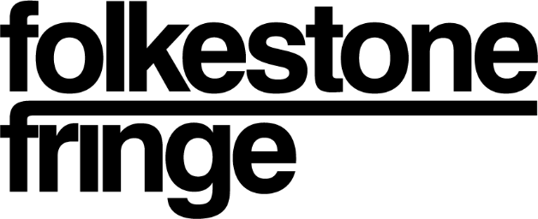

This application pack is available in different formats via our website, if you require something not listed, please let us know
About GLUE
Folkestone Fringe launches brand new curatorial platform, GLUE.
Created in response to a year of cancelled degree shows, inaccessible studios and cuts to staff and budgets. GLUE addresses dwindling opportunities for art students and supports exhibiting alongside the acclaimed Creative Folkestone Triennial.

GLUE begins with an open call running from 1st June - 1st July 2021. The open call welcomes submissions from artists, curators or collectives who are final year students, recent graduates, and postgraduate students from UK art schools or *alternative programmes.
GLUE seeks artists, curators and collectives who are energetic and entrepreneurial. This open call is for people who may have missed the catapult moments that degree shows can provide and are looking to create opportunities that define their futures.

Part of the Folkestone Fringe Triennial programme, the commissions are for two separate contemporary exhibitions in Folkestone, the first taking place throughout September and the second taking place throughout October. Capitalising on the energy of the Creative Folkestone Triennial, GLUE requires proposals that are innovative and ambitious. The two successful candidates will be announced late July.
Folkestone Fringe is committed to developing long term relationships with artists if you miss out on this occasion it does not eliminate the potential of us working together in future. We are an open and welcoming organisation, always on the lookout for creating connections.
*Alternative programmes may range from non-accredited educational courses to peer-led learning collectives. We will consider applications that demonstrate equivalent commitment to learning and development, accompanied by exhibition experience.
Brief:
What’s Happening, Exactly?
Folkestone Fringe poses the question, What’s Happening, Exactly? in response to the Creative Folkestone Triennial - “The Plot”. Using this question as a title to frame our activity throughout the programme period.
This question arose out of lockdown, when our homes and neighbourhoods became our world, and many people came to see their immediate surroundings differently. It also affected some of our deepest relationships – family, friends, education, work colleagues – fracturing some and forging others. Since then, we have used this open question to assess our relationship to circumstances globally, reflecting on the Refugee crisis, racial and ethnic inequalities & the climate emergency.
Our invitation to you is to use this question as the contextual framework and jumping off point for your GLUE submission.
What could a curator be?

From historical contexts to contemporary practices, curating exists across different forms and philosophies. GLUE seeks a curator who will create connections between artists, ideas, and locations. The curator will develop meaning within this context, and respond to the open call question - What's Happening, Exactly?

Being selected for the 2021 programme includes:

- The responsibility to curate and project manage an exhibition as part of the Folkestone Fringe Triennial 2021
- Production costs and artist’s fees covered; each exhibition has an allocated budget of £1800
- Benefitting from marketing and installation support from Folkestone Fringe team
- Support to host a launch event, including professional documentation
- Printed in GLUE’s debut publication
- Professional development opportunities, including peer networking. We will introduce you to other artists and curators, and help you gain an insight into the projects happening in Folkestone. We are well connected to the wider community, and if appropriate to your project we can introduce you to relevant groups of people
- Responding to the curatorial theme of What’s Happening, Exactly?
- Curatorial and production mentorship, from selected cultural professionals
- Contributing to Folkestone Fringe digital output, such as social media takeovers etc.
- Being part of a network of other participating artists in the Folkestone Fringe Triennial

Planned Engagement:
Exhibition 1 – September 2021
Exhibition 2 – October 2021

How to apply

To apply, please complete the below information and send to Hannah@folkestonefringe.com
We welcome applications in different formats including audio, video etc. If there are other formats that are more accessible to you, please contact Hannah@folkestonefringe.com

- Project proposal, unpublished (yet to be conceived) or existing (development of former exhibition)
- A clear concise description of the proposal and how it relates to the theme of What’s Happening, Exactly? (300 words max)
- A technical description of the project, specifying who you would choose to exhibit, and why. In the case of existing projects, please specify medium, dimensions etc. if appropriate
- Confirmation that project execution is achievable within the provided budget. Your exhibition budget totals £1800. You can choose how to distribute the funds; one example would be £300 for curator and £300 each for 5 artists
- Images or rough sketches that allow visualisation of proposed project. You can include these as an email attachment or provide a WeTransfer link.

Project Proposal:

- CV (max 2 pages) included as an email attachment

- Short portfolio, including a brief bio (250 words max) and 5 examples of your work.
You can include work examples as an email attachment, provide website links below or send via WeTransfer. Please clearly name your files.

Bio:

- Are you applying as an individual curator or as a collective?

- Which is your preferred exhibition period?

